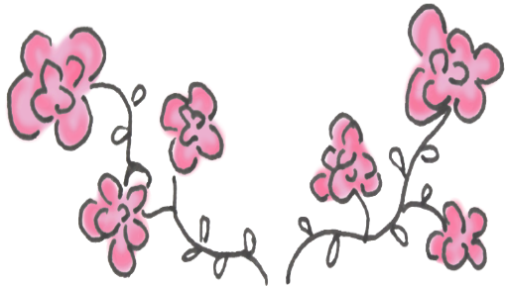

**Adoring Blossoms**

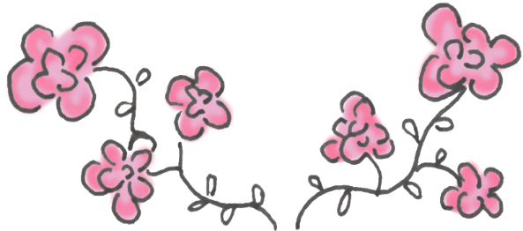

Providing you with the best of flowers for your special moments.

www.adoringblossoms.com  
Email: info@adoringblossoms.com

Telephone #: 000-000-0000  
Address: County Avenue, Shop no. 12, Jackson City, NY